Pop-Up Buoy User’s Guide

(Gen 3/Rev 5.3)

Table of Contents

1. Background 3

2. Highlights 4

3. Specifications 4

3.1. Temperature 4

3.2. PAR 4

3.3. Pressure 4

3.4. Tilt 4

3.5. Power 5

3.6. Data 5

3.7. Clock 5

3.8. Release 5

3.9. Physical Parameters 5

4. Overview 6

4.1. Phase 1 – On Bottom 6

4.2. Phase 2 – Profile 6

4.3. Phase 3 – Under Ice 6

4.4. Phase 4 – On Surface 6

4.5. Example 7

5. Interface 8

5.1. Arduino IDE 8

5.2. Program (Sketch) Descriptions 8

5.3. Uploading Programs (Sketches) 9

6. Connecting to the PCB 15

6.1. Temperature Sensor 15

6.2. PAR Sensor 16

6.3. Pressure Sensors 17

6.4. Power 18

6.5. GPS Antenna 19

6.6. Iridium Antenna 20

6.7. USB (to Computer) 21

7. Preparing the Instrument for Deployment 22

7.1. Pre-Deployment Checks 22

7.2. Pre-Deployment Test Program 22

7.3. Battery and Data Calculator 24

7.4. Final Programming of the Unit 27

7.5. Installing the End Cap 31

7.6. De-pressurizing the Float 32

7.7. Programming the Burn-Wire Release 33

7.8. Setting the Release Mechanism 35

8. Post-Deployment 36

8.1. Iridium Line Rental and Credits 36

8.2. Data Transmission Protocol 36

8.3. Sending Commands to Pop Up Buoys 36

8.4. Data Processing 38

# Background

The Pop-Up Buoy was developed as a unique product designed to take measurements while sitting under sea ice in the Arctic - to fill the gap in available technology between year-round deeper moorings and surface-based sampling in the summers. Measuring just under sea ice is of particular interest because the conditions there play a critical role in shaping one of the world’s most highly productive eco-systems. However, because of the harsh and unpredictable environment of shifting and breaking ice, actually acquiring measurements close to the ice during the Winter and Spring without losing instruments has been notoriously difficult. Because of the unique conditions, it needed to be **robust, inexpensive, and expendable, but sophisticated enough to acquire oceanographic-quality data.**

Cost was by far the driving factor in most of the design decisions and led to some atypical outcomes, such as the independent burn wire release and stripped down sensors. Since the floats only provide 1 profile of the water column, it was desirable to keep the cost around $3,000 per float. From a program-level perspective, the extremely low cost (compared to other instruments) is what makes the instrument a viable option for collecting data.

The instruments are designed to be deployed from a research vessel during the ice-free season, where they remain anchored on the bottom for many months until the surface is completely covered in sea ice. At a designated time for each device, a timed release is triggered which allows the buoys to float upward in the water column, collecting a vertical profile of the water column, until they reach the ice. The buoys remain under the ice until they are forced out by break-up and melting, transmitting their data to shore via satellite when they do arrive at the surface.

This third generation of instruments measures temperature, Sea Surface Temperature (when drifting at surface), PAR, Depth, and fluorescence (optional). It also has GPS and Iridium modules for location and transmission.

# Highlights

* Sensors: Temperature (Topside), SST (Underside Temperature), Pressure, PAR, Tilt, GPS, fluorescence (optional)
* Iridium SBD (Short Burst Data) Two-way communication
* Low Cost: ~$3,000 per unit
* Utilizes ”Arduino MEGA” development board

# Specifications

## Temperature (Topside and Underside/SST)

Sensor: US Sensor NTC Thermistor Probes

Absolute Accuracy: ±0.01°C or better

Range: -5°C to +70°C

Resolution: 0.0006°C *@ -2°C*

0.001°C *@ 10°C*0.002°C *@25°C*  
0.01°C *@50°C*

## PAR

Sensor: Skye Instruments TAG-PARQ (Special Build)

Absolute Accuracy: ±3% or better

Range: 0 to 1000 mol/m2s

Resolution: 0.048 mol/m2s

## Pressure

Sensors: [Keller PA-4LD OEM Pressure Transmitter](http://www.keller-druck.com/picts/pdf/engl/4ld_9ld_e.pdf)

Absolute Accuracy: ±70cm (10 bar)

Range: 0 to 100m (10 bar)

Resolution: 0.3cm (10 bar)

## Tilt

Sensor: [ADXL345 3-Axis Digital Accelerometer](http://www.analog.com/media/en/technical-documentation/data-sheets/ADXL345.pdf)

Absolute Accuracy: Depends on Mounting/Calibration

Sensor is accurate for Changes as little as 1.0°

## Power

Primary Batteries: 9V, 42Ah Alkaline Battery Pack (18 Standard D Cells)

RTC Battery: 12.5mm Lithium Coin Cell (Energizer CR1220=40mAh)

GPS Backup Battery: 12.5mm Lithium Coin Cell (Energizer CR1220=40mAh)

Sampling Current: On Bottom: 78mA for 2.5 seconds/sample

Searching for GPS: 114mA for up to 180 seconds

Sending Iridium Data: 200mA average continuous *plus*

500mA inrush for 20 seconds

Sleep Current: 15A

## Data

Storage: microSD or microSDHC card: 1GB to 32GB (FAT16 or FAT32)

Sample Limit: Limited by battery power and sample intervals, not storage capacity

## Clock

Unit: DS3234: RTC with Temperature Compensated Crystal Oscillator

Maximum Error: 1.05 minutes/year (0°C to 40°C)

1.84 minutes/year (-40°C to 85°C),

## Release

Burn Wire Unit: SubSeaSonics TR-45

Maximum Time: 170 Days after programming

Depth Rating: 244 meters

Maximum Load: 40 lbs on Burn Wire Release Link

200 lbs on Main Release Link

Burn Wire Unit: DBV Release Cylinder

Maximum Time: 24 months after programming

Depth Rating: 2000 meters

Maximum Load: 300 lbs on Burn Wire Release Link

Burn Wire Unit: DBV Release Block

Maximum Time: 24 months after programming

Depth Rating: 2000 meters

Maximum Load: 300 lbs on Burn Wire Release Link

## Physical Parameters

Pressure Housing: 12” Trawl Float

Depth Rating: ** pressure sensor rated to 100m or 300m is limiting factor.

Trawl Float rated to 500m, Fluorometer rated to 600m.

Net Buoyancy: ~15 lbs. (freshwater, no ballast)

~8 lbs. (freshwater, ballasted)

Length: 35.0 in (88.9 cm) from top of end cap to bottom of main release link

Weight in Air: 0.0 lbs (0.0 g)

Weight in Water: 0.0 lbs (0.0 g)

# Overview

The Pop-Up Buoy has a 4 phase deployment program. Each of these phases is run sequentially. The dates and times when each phase starts and ends are based on user configuration. For more information on configuring dates and times, see Section 6.5.

## Phase 1 – On Bottom

During Phase 1, the Pop-Up Buoy is assumed to be anchored to the bottom. The unit will simply wake up, take a sample from each sensor, and go back to sleep. The *bottom sample interval* is nominally 1 hour, but can be changed by the user.

## Phase 2 – Profile

During Phase 2, the Pop-Up Buoy actively waits on the bottom until it senses a change in depth. Once the unit senses a change in depth, it will take samples from each sensor at 4 times per second, for a set amount of time (nominally 90 seconds), collecting a vertical profile of the water column on its way to the surface (or ice).

The unit is designed to wake up a significant amount of time before the scheduled release (nominally 6 hours). Since the burn wire release uses an independent clock, this ensures the unit will sense the start of the profile, regardless of any drift in either clock or minor offsets when programming either.

## Phase 3 – Under Ice

The unit will take sample and search for a GPS location at standard interval (nominally 1 hour). As soon as the unit is able to obtain a GPS fix, it will begin attempting to transmit data via Iridium. If any messages are sent successfully, the unit will continue sending messages until all data has been sent. The unit will also only wait 5 minutes in between samples if data is sent successfully in order to transmit data back more quickly. The unit can also receive messages when it is transmitting data.

Once all data has been sent, the unit will revert into a ‘drifter’ mode, where it will sample, search for a GPS fix, and attempt to transmit its position once per day.

## Example

The following is an example of a deployment description which is provided after programming a unit for deployment. This is from a deployment on the DY17-08 Cruise. All items in parentheses ( ) or brackets [ ] are configured by the user.

Deployment Schedule:

--PHASE 1--

Unit will start sampling [Sep 27 2017 00:00:00] and take a sample every (6h,0m,0s)

--PHASE 2--

Release Expected [Feb 20 2018 15:00:00] (<--Set Burn Wire Release for this exact time/date.)

Unit will wake up (2h,0m,0s) before scheduled release and wait for profile.

Start of profile will be triggered by a change in depth of (3 meters).

Profile will sample at 4 Hz for (0h,1m,30s) seconds before proceeding to phase 3.

If unit does not sense the release within (4h,0m,0s) of waking it will assume it missed the profile and proceed to phase 3.

--PHASE 3--

Unit will assume it is under ice until [Feb 20 2018 18:00:00]

Unit will take a sample every (1h,0m,0s) and search for GPS location only once a day to conserve battery power.

--PHASE 4--

Unit will no longer assume it is under ice after [Feb 20 2018 18:00:00]

Unit will take a sample and search for GPS location every (1h,0m,0s)

Unit will search for GPS (1 times) for (0h,2m,0s) with (0h,0m,20s) between each attempt to confirm a lock.

If unit does successfully find a GPS lock, it will attempt to send data back in the following order:

1-File Summary, 2-Profile Data, 3-Under Ice Data, 4-Bottom Data

If any messages send successfully, the unit will automatically make another attempt in (0h,5m,0s)

Otherwise, the unit will return to sampling and searching for GPS every (1h,0m,0s)

# Interface

## Arduino IDE

The Pop-Up Buoy Uses the Arduino IDE (Integrated Development Environment) to upload programs to the Buoy. The Arduino IDE is a software package that lets users write and upload code directly to the microcontroller on the device.

There are 2 different programs that must be uploaded for checking and deploying the instrument. Instructions for how to upload programs and how to configure the instrument are in subsequent sections of this guide.

**Be sure to only use Version 1.8.5 of the Arduino IDE.** There are difference in library packages and the way programs are compiled which may have unpredictable consequences if another version is used.

The PCB Stack must be connected to 9V power when uploading and using programs. Since power is provided through USB Cable, the unit will still communicate if not connected to power, but will circuits and sensors will not initialize properly, causing errors. Detailed instructions are provided in Section 5.3.

## Program (Sketch) Descriptions

Pop-Up Buoy uses 3 different programs, all described below. The Arduino IDE calls these different programs ‘sketches’.

**Setup and Sensor Check** (*PopUp_5.3_SetupAndSensorCheck.ino)*

This program is used during the assembly and testing phases to test that various sensors and utilities on the units are working properly. Once uploaded and the serial monitor is launched, the user is provided a status summary of the unit and a menu to check sensors and utilities one by one. If there are any problems that require changes such as re-connecting a sensor, it is usually necessary to close the serial monitor and re-upload the program. This will allow all sensors to initialize properly.

For details and instructions on using the Setup and Sensor Check Program, see the Pop-Up Buoy User’s Guide.

**Deployment** (*PopUp_Deployment_5.3_Arduino_1.8.5.ino)*

This program is used for deployments and calibrations. All deployment parameters (dates, sample intervals, etc.) must be manually entered into the program before uploading.

Once the program is uploaded and the serial monitor is launched, the user will be provided a long dialog confirming deployment parameters and verifying unit status. This dialog should be reviewed carefully for any possible errors.

For details and instructions on configuring units for deployment, see the Pop-Up Buoy User’s Guide.

## Uploading Programs (Sketches)

**To upload different programs to the Pop-Up Buoy, follow the steps below:**

1. Connect all necessary sensors, antennas, coin cell batteries, and micro SD Card to unit electronics.
2. Connect unit to Power Supply (9V Battery or Power Supply with 9V, 1A with power on). Note: **Do not use the main battery packs for testing or calibrating as it will deplete power necessary for the final deployment.**
3. Connect unit to computer via USB cable
4. Open the Arduino IDE (Integrated Development Environment). **Be sure to use version 1.8.5.**
5. Open appropriate sketch
6. Select Board
   * *Tools 🡪 Board 🡪 Arduino Mega 2650 or Mega ADK*
7. Select COM Port
   * Check *Device Manager 🡪 Ports* to find correct port
   * *Tools 🡪 Serial Port 🡪 COM__*
8. Compile Sketch
   * *Ctrl + R* or *Sketch 🡪 Verify/Compile*
   * Should Read “Done Compiling” when complete
9. Upload Sketch
   * *Ctrl + U* or *File 🡪 Upload*
   * Should Read “Done Uploading” when complete
10. Launch Serial Monitor
    * *Ctrl + Shift + M* or *Tools 🡪 Serial Monitor*
    * Note: The baud rate should be set to 115200 (lower right-hand corner after launching Serial Monitor)
    * Note: 9V Power MUST be supplied and turned on before the serial monitor is launched. It is possible to upload sketches without external power, but power must be supplied for sensors to initialize properly when serial monitor is launched.
11. To upload a different sketch, close the serial monitor and begin at Step 5. It is not necessary to disconnect the unit from power or close the Arduino IDE.

# Preparing the Instrument for Deployment

For a proficient user, it should take about 30 minutes to check and prepare each Pop-Up buoy for deployment. This includes checking battery voltages; checking sensors; configuring sample intervals, dates, and times; installing the end cap; de-pressurizing the float; programming the burn-wire release; and arming the release for deployment.

## Pre-Deployment Checks

* Check the main battery voltage (Should be ~9.68V)
* Check RTC and GPS coin cell battery voltages (Should be ~3.3V)
  + Touch one voltmeter probe on top of coin cell battery and the other probe to any black test point on the board
* Check that a micro SD Card is inserted
* Check that all sensors and antennas are plugged securely into electronics and wires will not get fouled or cut when installing the end cap. Be careful to observe polarity and location of the 2-pin connectors for PAR, Temperature, and Power as they are all the same size. See Section 6.1 for details.
* Ensure electronics stack is securely fastened to PCB Frame with standoffs, screws, and lock-washers
* Tape a desiccant pack to the back of the PCB Frame, also securing the electronics stack

## Pre-Deployment Test Program

Follow the procedures in section 5.3 to upload the sketch named *PopUp_SetupAndSensorCheck_4.0_12-8-17*

After Launching the Serial Monitor, you will be given a status menu of options. Simply type a number into the dialog at the top of the serial monitor and press Enter to select each option. Type ‘Q’ into the dialog and press Enter to stop any of the sensor check functions.

**YOU MUST SET THE CLOCK AND CLEAR THE MICRO SD CARD USING THIS PROGRAM.** All other functions are a good verification that utilities and sensors are working, but are not necessary to do before deployment.

To verify that utilities and sensors are working:

1. Display Status
   * Display the SD Card status, RTC time/date, and sensor values.
   * Verify that the SD card is communicating properly and RTC is keeping time with the status function
   * If the SD card is displaying an error, try a [Loopback Test](https://support.arduino.cc/hc/en-us/articles/360020366520-How-to-do-a-loopback-test).
2. Set RTC Time/Date
   * Follow the prompts to set the unit’s clock time and date. Set the clock as close to official time as possible - this way the unit’s clock can be compared to time obtained from GPS and clock drift can be accounted for.
   * ALWAYS USE UTC
3. Display SD Card Data
   * Display the contents of the SD Card. **The SD Card should always be empty before deployment so that only deployment specific data is transmitted via Iridium.**
4. Check Temperature Sensor
   * Display the current temperature sensor reading and the reference resistor reading.
   * The responsiveness of the temperature sensor can be checked by simply holding the probe between 2 fingers and looking for an increase in temperature.
   * The reference resistor should always read close to 10 kohms.
5. Check Pressure Sensors
   * Display the current pressure measurement value and calculated depth for both sensors.
   * The responsiveness of the sensors can be checked by covering the port with your fingertip
6. Check Accelerometer
   * Display the current accelerometer reading and approximate angle of the sensor.
   * The accelerometer should read approximately 180 degrees from vertical when the sensors are resting on the surface of a table. It should read approximately 0 degrees when the sensors are pointed upright as they are when the unit is deployed.
7. Check PAR Sensor
   * Display the current PAR sensor reading.
   * The PAR sensor should read close to 0 mol when the sensor is covered and dark. The sensor should read low values (under 10 mol) when exposed to interior/artificial light. The sensor should read high values (100-1000+ mol) when exposed to outside sunlight, even if indirect.
8. Check GPS
   * Turn on the GPS module and attempt to find a GPS fix. Display processed NMEA data to the Serial Monitor.
   * The antenna must have clear view of the sky to be able to obtain a GPS fix. **This does not need to be done during final checks**, especially since the unit will probably be configured indoors.
9. Check Iridium
   * Turn on the Iridium module and attempt to send a message
   * The antenna must have clear view of the sky to be able to obtain a GPS fix**. This does not need to be done during final checks**, especially since the unit will probably be configured indoors.
10. Delete all SD Card Data
    * **The SD Card should always be empty before deployment so that only deployment specific data is transmitted via Iridium.**
    * If preparing for deployment and the card is not empty, enter ‘X’ at the main menu. Be careful as this does permanently delete all SD Card Data.

## Battery and Data Calculator

Use the Battery and Data Calculator spreadsheet (*Pop-Up* *Battery and Data Calculator - Rev 4.0.xlsx)* to verify unit’s battery will last through the full deployment using desired sample intervals and cutoff times and dates. The Battery and Data Calculator also automatically calculates the time that should be programmed into the burn wire release so that it is synchronized with the Pop-Up Buoy.

See Section 4 for descriptions on the unit’s programming

To use the Battery and Data Calculator:

1. Fill in all Unit Settings which are highlighted in yellow.



**Current Time:** The current time and date. Be sure this time zone and the time zone of the unit’s RTC are matched. It is best to use local time to avoid errors in setting the burn wire release.

**Unit Start:** The time and date that the unit will take its first sample. **This must be after the current time and date**. Set the Unit Start for several hours or days in the future to ensure this does not lapse while programming the unit.

**Release Time:**  The time and date that the unit will release from the bottom to collect a profile. This value and the Current Time are used to calculate the Burn Wire Programming settings which are showed in green. This value should be the exact time and date that the release is expected. The unit will automatically wake up before the release is expected and wait for the profile to begin.

**Ice Free Date:** The time and date that the unit is earliest expected to be free of the ice. This is primarily used as a battery saving measure. This can be set for just after the release time if there is adequate battery power or the unit may actually surface in open water.

**Bottom Sample Interval:** The number of seconds between samples while the unit is on the bottom. This is nominally set to 3600 (1 hour) as measurements should not change much while on the bottom.

**Pre-Release WakeUp Interval:** The number of seconds that the unit will wake up before the release time. This is nominally set to 7200 (2 hours) to provide a huge buffer for drift in the burn wire’s clock or small offsets when programming.

The worst case timing error for the burn wire releases is +/- 2 minutes per month, plus an additional 10 to 20 minutes for the actual erosion of the link to take place. The burn wire can also only be set in 7 or 8 minute increments. The worst case timing error for the Pop-Up Buoy’s internal clock is 1.84 minutes per year. This can cause a total worst case error of up to 40 minutes over 6 months. **The Pre-Release WakeUp Interval should be set to a minimum of 3600 (1 hour).** 2 Hours is probably adequate, but until the burn wire releases have been used for several seasons, some extra buffer should be added.

**Under Ice Sample Interval:** The number of seconds between samples after the unit has released from the bottom. This is nominally set to 3600 (1 hour) as data is more critical and variable here than on the bottom, but faster sample intervals will likely utilize too much power.

**Profile Length:** The number of seconds that the unit will collect a profile for after sensing a change in depth when it releases from the bottom. The profile length is nominally 90 seconds. Profile samples are collected at 4 Hz and the Pop-Up Buoy ascends at a rate of approximately 1m/s. Increasing the length of the profile will substantially increase the amount of data that needs to be transmitted because samples are collected quite rapidly. Avoid setting the profile length to longer than 2 minutes.

1. Fill in the field below (in yellow) to test check how many days the unit can stay under ice before surfacing.

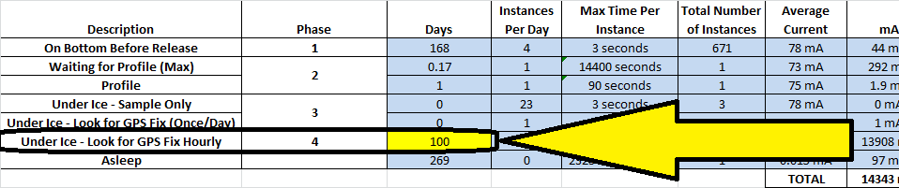

1. Use the graph of Battery Power and Power Estimate Table to check that the unit has enough reserve battery power to surface and send all data back. The unit should have at least 5-10% of its power in reserve, even for the worst case scenario.

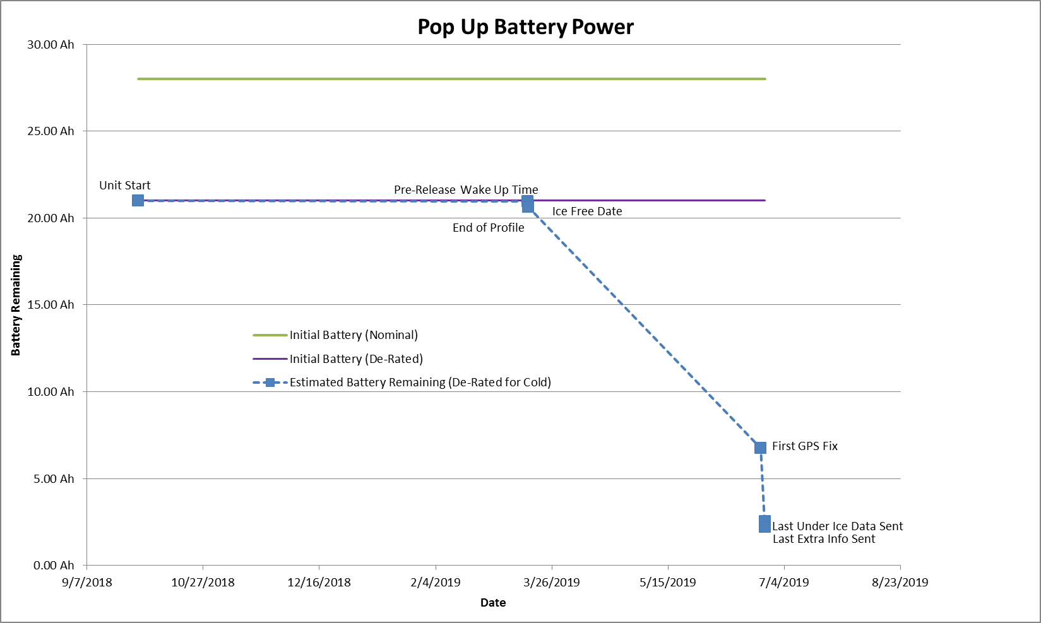



1. If the graph and table above do not show that the unit has adequate power reserves, change the deployment parameters to improve power usage.
   * Set the “Ice Free Date” to several weeks or months after the Release Date. This will provide the largest power savings.
   * Increase sample intervals or reduce profile length to reduce the amount of power used sampling and also reduce the amount of data that must be transmitted.

## Final Programming of the Unit

1. Complete Pre-Deployment checks show in Sections 7.1 and 7.2.
2. Open the sketch titled *PopUp_Deployment_4.0_9-17-17*. Do not upload the sketch yet.
3. Setting the deployment parameters (sample intervals, release time, etc.) requires manually changing the values in the sketch. This section starts on line 57 and is clearly denoted with asterisks (***************************************************************)

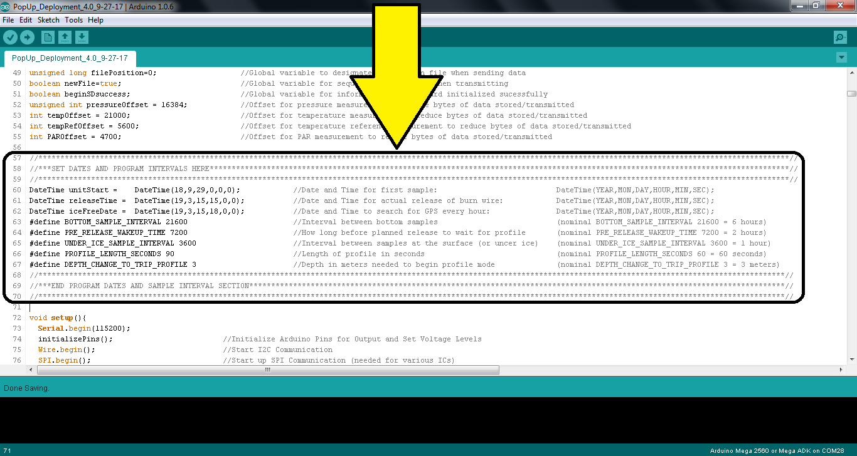

1. The parameters are explained below.
   * **Carefully note the format of the Date Times**
   * **Only change the numerical values from lines 60 to 67**. Making any other changes could cause the program and the entire deployment to fail. Anything after the double // in each line is a comment (in light grey) and is not processed by the program
   * **Parameters should match those used in the Battery and Data Calculator.**

**unitStart –** The time and date that the unit will take its first sample. **This must be after the current time and date**. Set the Unit Start for several hours or days in the future to ensure this does not lapse while programming the unit.

Format:DateTime(*Year, Month ,Day ,Hour ,Min, Sec*);

*\*Note: All values less than 10 should be a single digit. (i.e. ‘7’ not ‘07’)*

*\*Note: Year value should be years after 2000. (i.e. ‘19’ for 2019)*

**releaseTime –** The time and date that the unit will release from the bottom to collect a profile. This value and the Current Time are used to calculate the Burn Wire Programming settings which are showed in green. This value should be the exact time and date that the release is expected. The unit will automatically wake up before the release is expected and wait for the profile to begin.

Format:DateTime(*Year, Month ,Day ,Hour ,Min, Sec*);

*\*Note: All values less than 10 should be a single digit. (i.e. ‘7’ not ‘07’)*

*\*Note: Year value should be years after 2000. (i.e. ‘19’ for 2019)*

**BOTTOM_SAMPLE_INTERVAL –** The number of seconds between samples while the unit is on the bottom. This is nominally set to 21600 (6 hours) as measurements should not change much while on the bottom.

Format: *xxxxx*

(Any integer value up to 4,294,967,295)

**PRE_RELEASE_WAKEUP_INTERVAL –** The number of seconds that the unit will wake up before the release time. This is nominally set to 21600 (6 hours) to provide a huge buffer for drift in the burn wire’s clock or small offsets when programming. The worst case timing error for the burn wire releases is +/- 2 minutes per month, plus an additional 10 to 20 minutes for the actual erosion of the link to take place. The burn wire can also only be set in 7 or 8 minute increments. The worst case timing error for the Pop-Up Buoy’s internal clock is 1.84 minutes per year. This can cause a total worst case error of up to 40 minutes over 6 months. **The Pre-Release WakeUp Interval should be set to a minimum of 3600 (1 hour).** 2 Hours is probably adequate, but until the burn wire releases have been used for several seasons, some extra buffer should be added – hence the 6 hour nominal setting.

Format: *xxxxx*

(Any integer value up to 2,147,483,647)

**UNDER_ICE_SAMPLE_INTERVAL –** The number of seconds between samples after the unit has released from the bottom. This is nominally set to 3600 (1 hour) as data is more critical and variable here than on the bottom, but faster sample intervals will likely utilize too much power.

Format: *xxxxx*

(Any integer value up to 2,147,483,647)

**PROFILE_LENGTH_SECONDS –** The number of seconds that the unit will collect a profile for after sensing a change in depth when it releases. The profile length is nominally 60 seconds. Profile samples are collected at 4 Hz and the Pop-Up Buoy ascends at a rate of approximately 1m/s. Increasing the length of the profile will substantially increase the amount of data that needs to be transmitted because samples are collected quite rapidly. **Avoid setting the profile length to longer than 2 minutes.**

Format: *xx*

(Any integer value up to 2,147,483)

**DEPTH_CHANGE _TO_TRIP_PROFILE –** The change in depth (in meters) that the unit must sense to start the profile while in Phase 2. This value may be as small as 1, but should be higher depending on tidal range and the Pre-Release WakeUp Interval. If the Pre-Release WakeUp Interval is set to 6 hours, the unit will wait for a depth change for twice as long as the interval – up to 12 hours total. **The DEPTH_CHANGE _TO_TRIP_PROFILE should be larger than the maximum tidal range within a 12 hour period (or double the Pre-Release WakeUp Interval).** 3 or 4 meters is probably a reasonable value for most environments.

Format: *xx*

(Any integer value up to 100)

1. Double Check all parameters. Below is an example of how the parameters would look for the settings shown in Section 7.3.

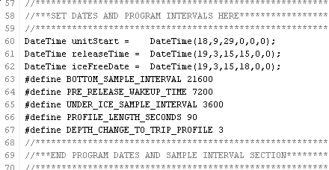

1. Ensure Unit is connected to 9V Power and upload the sketch as shown in Section 5.3. If preparing the instrument for final deployment, it is ok to use the main battery as the 9V source.
2. After Launching the Serial Monitor, it should display a dialog containing all details of the deployment procedure and timeline. See the example below.

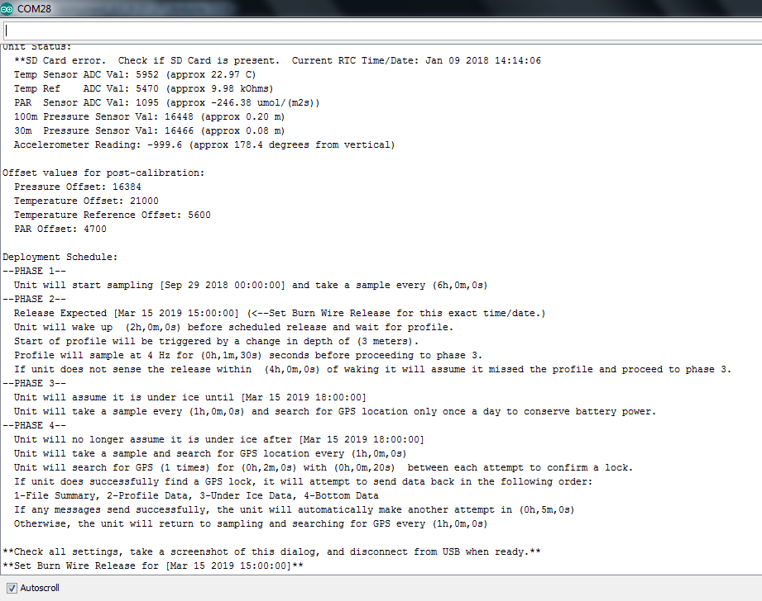

1. **Verify all times, dates, sample intervals, and sensor functions.** Be sure all details are as expected and dates and times match those in the Battery and Data Calculator spreadsheet. There are no other lights or sounds to confirm the unit has been set up properly. This window and the description are the final verification. In the example above, the first line indicates an SD Card error and the 4th line indicates an erroneous PAR reading. Both must be investigated and fixed before deploying the instrument.
2. **Take a screenshot or otherwise record the dialog for record keeping. This contains important information for post-processing data and is the only record to look at if the deployment does not go as expected.**
3. Write down the Burn Wire Release Time and ensure this matches what is in the Battery and Data Calculator for programming the release.
4. Once all settings have been confirmed, simply unplug the USB cable from the electronics. You are now ready to install the end cap and set the burn wire release

## Installing the End Cap

1. Ensure the main battery is connected to the electronics in the proper position.
2. Clean and lubricate both O-rings on the end cap. Clean the mating surfaces on the trawl float.
3. Carefully insert the end cap into the float, ensuring that no wires are pinched
4. Remove the vacuum port cap with pliers if it is in place.
5. Press the end cap firmly into the trawl float until the face seal is seated against the float. Some air will be compressed inside the float when doing this. If necessary, release the extra pressure by pressing the center valve on the vacuum port with a narrow tool to get the end cap to seat fully.

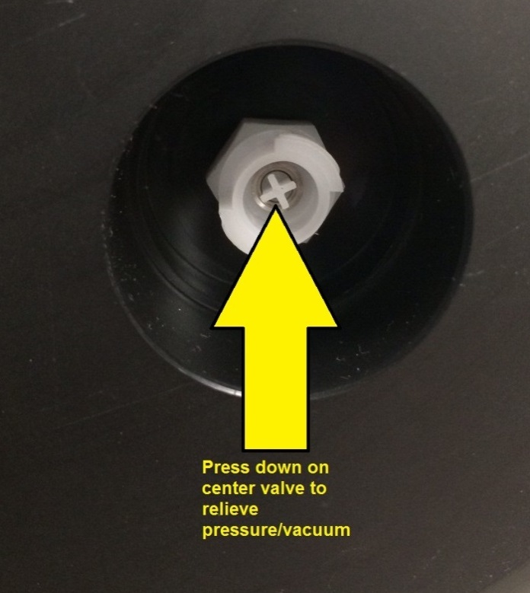

## De-pressurizing the Float (pulling a vacuum)

Once the end cap is installed, air must be removed from the trawl float to create a vacuum and hold the end cap in place.

1. Connect the quick-connect tubing to the vacuum port and turn the fitting 1/4 turn clockwise to lock in the connector.
2. Pump the inside of the float to a vacuum of roughly -15psi below ambient pressure. The air can be pumped out using an electronic vacumm pump or the Mity-Vac hand pump. A vacuum of -15psi will provide ~754 lbs of force holding the cap into place. If using the hand pump, be sure that the valve near the Mity-Vac nozzle is set to Vacuum.

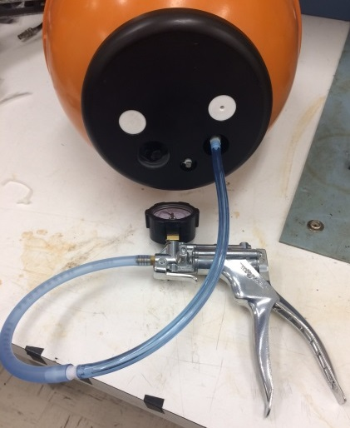 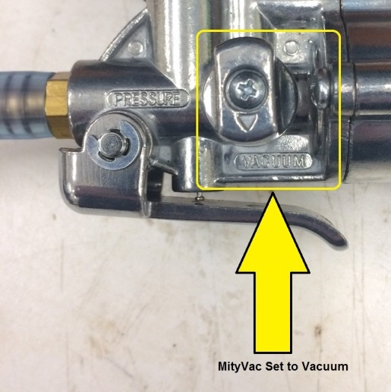

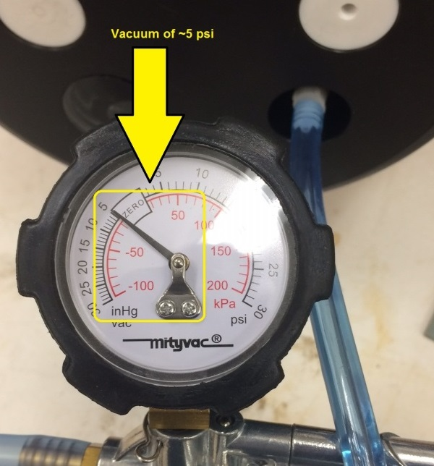

1. Disconnect the tubing from the vacuum port by turning the fitting 1/4 counter clockwise and removing it
2. **Replace the Vacuum port Cap.** The vacuum port is not watertight on its own. First, clean and lubricate the O-ring on the cap. Next, clean the mating surface on the end cap. Install the cap by pressing it firmly into the socket. Once installed, press down on the cap firmly to force the compressed air out and get it to seat as low as possible.

## Programming the Burn-Wire Release

See document “DBV Burnwire Programming Guide-July2019”

# Post-Deployment

## Iridium Network

In 2018 - 2019 we used the DoD DITCO network contract for paying for satellite transmission of data. In order to activate these Iridium modems we had to send them to NAL Research to get “whitelisted”, a process that essentially clears devices for use on a DoD network. The contract was renegotiated and became cost-prohibitive, so we switched to using an Inmarsat Gov contract from 2020 – 2021. In order to activate the Iridium modems, you have to contact Ben Carlson and provide the modem’s IMEI number, and ask to have that number added to the Inmarsat Gov contract. Once the device is activated on the contract we keep it active until all data has been transmitted. We generally don’t deactivate and reactivate because there is a $250 charge to re-activate an existing card. Once we deactivate something, we replace it with a new one because there is no activation fee for new SIMs. The SBD monthly fee plus estimated data transmission cost per float is about $230 for a full year: broken down by $13.45 monthly rate + ($1.03/1024000 bytes transmitted x

## Data Processing

See document \EcoFOCI_PopUp\Data\documentation\PUF Data Processing Instruction.txt

and the Background and Instruction Jupyter Notebook scripts located in \EcoFOCI_PopUp\Data\src.